LIHNN visit to LMI
June 4, 2024 11:51

Opposite Liverpool’s Catholic cathedral and next door to the Everyman theatre Liverpool Medical Institute is an unassuming Classical building in Hobnob-coloured stone. Two columns on the main entrance give it the air of a Post Office with delusions of grandeur, or perhaps the home of one of the University’s less-fashionable departments, anthropology or theology perhaps.
Once ins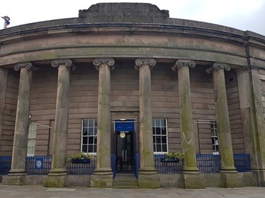ide however, a considerably more interesting building and collection reveal themselves. Like all good libraries it has a gallery level with books stretching from floor to ceiling. The main reception area featured plenty of leather armchairs and a gas fire – which, with coffee and biscuits as we arrived – proved very welcome on a grey March day with a bitingly-cold wind. Our guide for the day was Bill Taylor – Honorary Librarian, and a retired Consultant Histopathologist. He explained that the current building, completed in 1837, replaced The Bowling Green Inn where William Roscoe – who later campaigned against the slave trade – was born in 1753. At the rear of the building, back in the day, were alms houses, later replaced by a maternity hospital in which John Lennon was born. Beatles tour buses make regular stops outside the LMI to point this out to people – no doubt a source of fresh joy to the readers each time they experience it. And opposite the LMI stood a workhouse, now gone to make way for the Catholic cathedral.
The LMI is an independent charity, which provides postgraduate medical education, serves as a meeting place for its members, holds an amazing collection of medical books (of which more later) and can be hired for conferences and events. Among past presidents – listed on a board like church organists or boys’ 100m winners – were Dr R.J. Minnitt who pioneered the use of gas-and-air during labour, something millions of women have had cause to be grateful for. In keeping with the Classical building the entrance hall features the crest of the LMI picked out in mosaic, and a memorial to Cyril Clarke, who discovered how to prevent erythroblastosis fetalis – an obstetrical condition that once killed about a 1,000 people a year.
It would be nice to think the LMI’s council meetings feature port, sherry, and a butler in white gloves although given the splendid carpets and the propensity for over-animated doctors to shed crumbs, canapes might be deemed to be too risky a development. The council room featured some splendid wood panelling though, and Henry Park’s “book of Genesis,” - records of those he helped deliver into the world, among them Victorian Prime Minister W.E. Gladstone. The council room also features Dr Sylvester Richmond’s clock “The Old Doctor,” which once made an appearance on Antiques Roadshow.
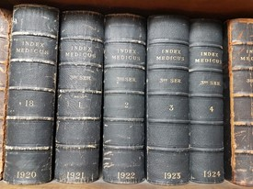The LMI library still receives occasional donations from members, catalogued by Librarian Anna Jackson, who gave us a tour of the rare books, held in rolling stacks in the basement. These include first editions of Charles Darwin’s On the origin of species and Florence Nightingale’s Notes on Nursing.
Further back in time were An inquiry into the causes and effects of the variolae vaccinae: a disease discovered in some of the western counties of England, particularly Gloucestershire, and known by the name of the cow pox by Edward Jenner, discoverer of the smallpox vaccine and, from 1532 Paul of Aegina’s Opus de re medica. And – going back to the C19th – Physician’s anatomical aid: a manikin of superimposed diagrammatic plates, designed to assist in surgery, diagnoses and general practice, proof that Messrs Dorling Kindersley and Usborne weren’t breaking new ground with the pop-up book. For Medline enthusiasts the LMI have a run of Index Medicus volumes which became Medline when the NLM MEDLARS system went online in 1971.
Having worked up a thirst we said our goodbyes – although Anna joined us later – to the LMI and moved on to The White Hart just round the corner. Not, so I’m told, an original interior like The Philharmonic but in all other respects fulfilling all the criteria for a top-notch boozer – dark, cosy, peaceful and serving Timothy Taylor’s for the connoisseur. Only the inevitable England batting collapse on the pub TV dampened the mood – even that, perhaps, like the rest of the day being a reminder of slower-paced, more civilized times past.

John Gale, Librarian
JET Library - Mid-Cheshire Hospitals NHS Foundation Trust
Steve Glover, Head of Library Services
Manchester University NHS Foundation Trusts

