Team Members
Points

So here it is, Merry Christmas
Answer the following general knowledge questions about Christmas. 1 point for each correct answer.
1 | In the song the 12 days of Christmas how many Lords were a-leaping?
 | Answer:
2 | What do Barbie, Buzz Lightyear, Bob the Builder and Teksta the Dog all have in common?
 | Answer:
3 | What year did Wham!'s Last Christmas first top the charts?
 | Answer:
4 | What was the full name of the angel who came to George Bailey’s rescue in “It’s a wonderful life”?
 | Answer:
5 | What was different about The Queen's Christmas message in 1959?
 | Answer:
6 | Which famous singer appears at the start of the animated film “The Snowman”?
 | Answer:
7 | What type of tree is the Trafalgar Square Christmas tree?
 | Answer:
8 | How many ghosts visit Ebenezer Scrooge in Charles Dickens “A Christmas carol”?
 | Answer:
9 | What is the second line of the poem that starts “Twas the night before Christmas, when all through the house”?
 | Answer:
10 | Which famous actor’s aunt played Betty Haynes in the film “White Christmas”?
 | Answer:

Everybody's having fun
There’s no theme to this year’s collection; just a miscellaneous selection of photographs. 1 point for each correct answer. (Thanks as always to Stephen Edwards for the picture quiz )
1 | 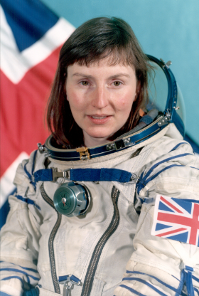 |  | 2 | 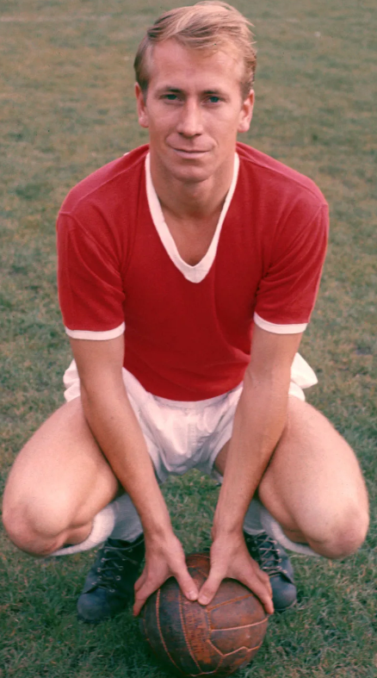
3 |  |  | 4 | 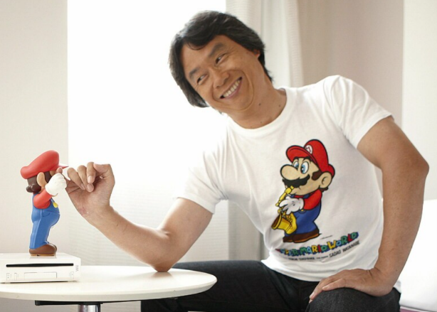
5 | 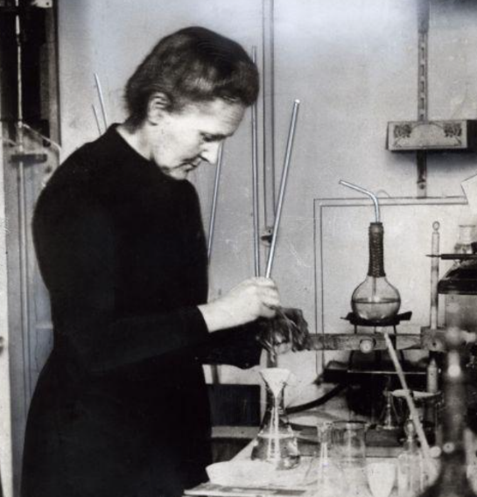 |  | 6 | 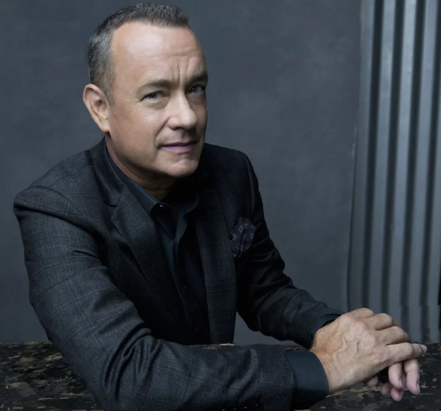
7 | 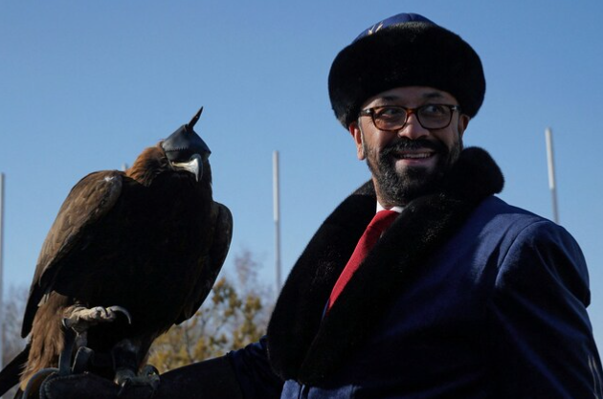 |  | 8 | 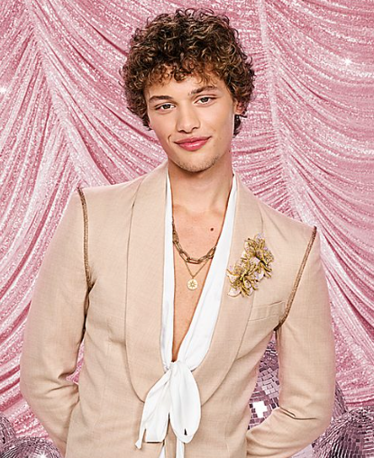
9 | 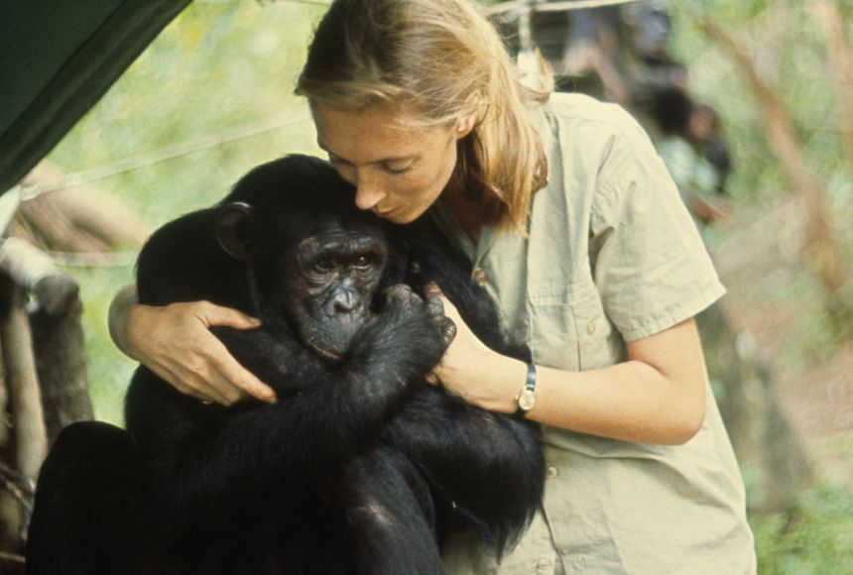 |  | 10 | 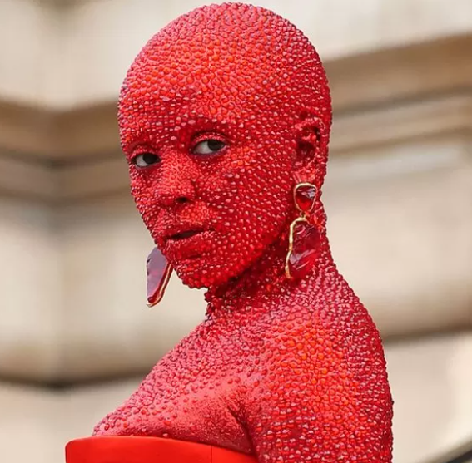
Look to the future now
The following are all scheduled to take place in 2024. One point for each correct answer.
1 |  | What will take place on 10 March 2024 in the Dolby Theatre?
 |  | Answer:
2 |  | What over the top event will take place in the Malmö Arena on Saturday 11 May
 |  | Answer:
3 |  | What international sporting event takes place in France from 28 August to 8 September 2024
 |  | Answer:
4 |  | What election will take place on 5 November 2024?
 |  | Answer:
5 |  | What era ending event is scheduled to take place on 23 November 2024 in the Rogers Centre in Canada?
 |  | Answer:

It's only just begun
The following are all first lines from songs which have been number 1 at Christmas. 1 point for the name of the song and 1 point for the band or singer.
1 | Oh, yeah, I'll tell you somethin'
 | Answer:
2 | We'll drink a drink, a drink
 | Answer:
3 | You could hear the hoof beats pound
 | Answer:
4 | Is this the real life? Is this just fantasy?
 | Answer:
5 | You were working as a waitress in a cocktail bar
 | Answer:
6 | Maybe I didn't treat you
 | Answer:
7 | Candlelight and soul forever
 | Answer:
8 | All around me are familiar faces
 | Answer:
9 | Call it love and devotion
 | Answer:
10 | I saw him standing there in the bakery
 | Answer:

